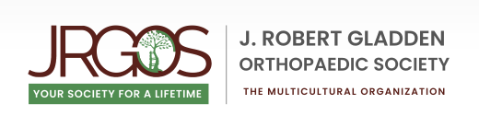

RESIDENT/JRGOS AGREEMENT

By signing this Resident Agreement and/or by receiving any guidance, advice, support, recommendations and resources from J. Robert Gladden Society (“JRGOS”) and its members, officers and directors or from the Resident Support & Success Committee (the “Committee”), I agree that JRGOS, its members, officers, directors, employees and agents (past and present) and the Committee and its members (hereinafter collectively, the “Released Parties”) shall not be liable or responsible in any way for any guidance, advice, support, recommendations, communications and resources that I may receive and for any harm, injury and damages resulting therefrom. I further agree not to make any demand or bring any claim or cause of action or seek damages of any kind against the Released Parties. I understand and agree that any information or records that I share, or communication that I have, with the Committee is not confidential and may be shared by the Released Parties without any liability. This agreement shall be binding upon my heirs, administrators, representatives and agents.

Agreed to by:
_______________________________ _________________________
Print Name Date

_______________________________
Sign Name

